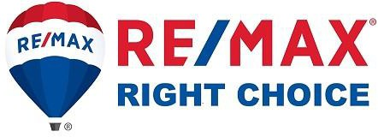

Presented by…

Table of Contents

Thank You Letter 3
My Resume/Background 4
Testimonials 5
RE/MAX Right Choice 6-8
RE/MAX # 1 “Nobody In the World Sells More Real Estate Than RE/MAX” 9- 23
My Focus 24
What I Know 25
My Three Vital Listing Agent Responsibilities 26
My Role 27
Your Role 28
My Success Plan For Your Home 29-31
Syndication 32
Seller’s Closing Costs 33
Field Card 34-36

Mr. and Mrs. Seller,

Thank you for the opportunity to meet with you about selling your home.

We take great pride in the work we do for those who put their trust in us, and our only goal is to create a win-win relationship that allows us to help you achieve your goals.

I’ve enclosed information about myself, RE/MAX Right Choice, RE/MAX, LLC, my success marketing plan, what you can expect from me, and what I expect from you.

Please take a few moments to read this packet prior to our meeting. This will allow us to

spend the majority of our time together answering your questions and focusing on what I

need to do to help you achieve your goals with the sale of your home.

I look forward to meeting with you.

My Resume/Background

Testimonials

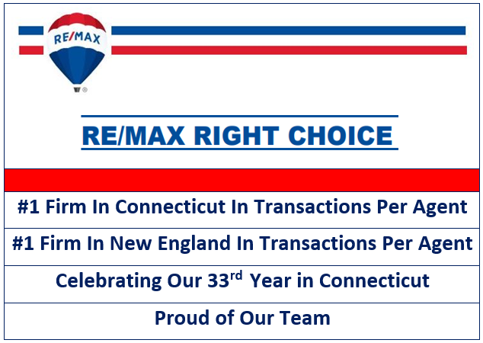

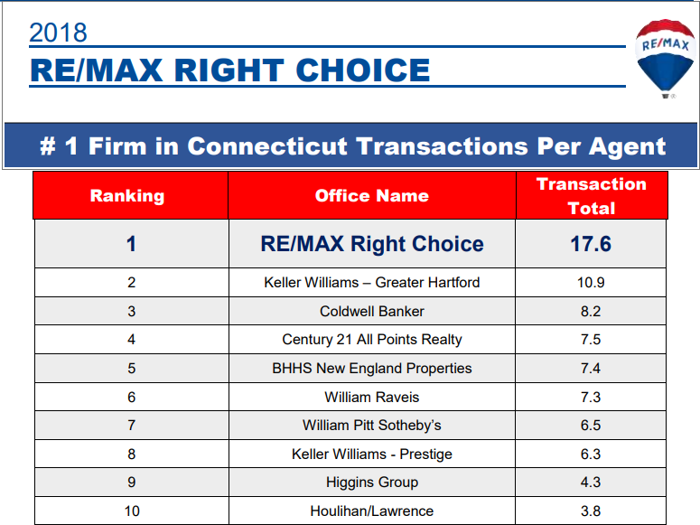

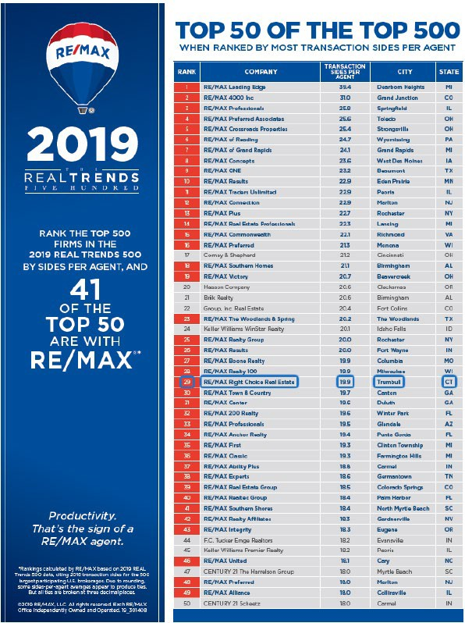

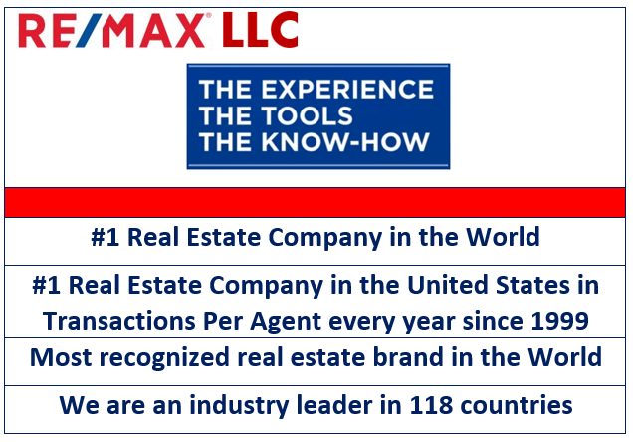

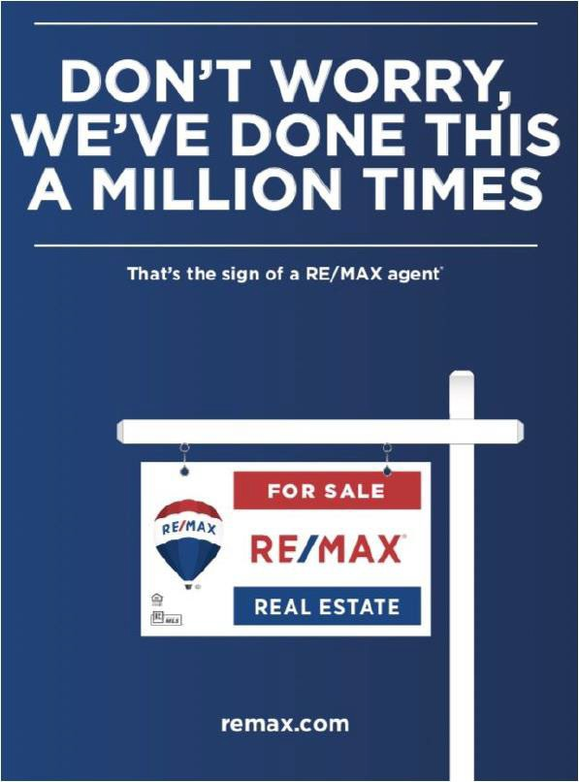

(As measured by residential transactions sides.)

RE/MAX By The Numbers

RE/MAX out produces other brands by 2 to 1 in North America and has been #1 in US home sales since 1999.

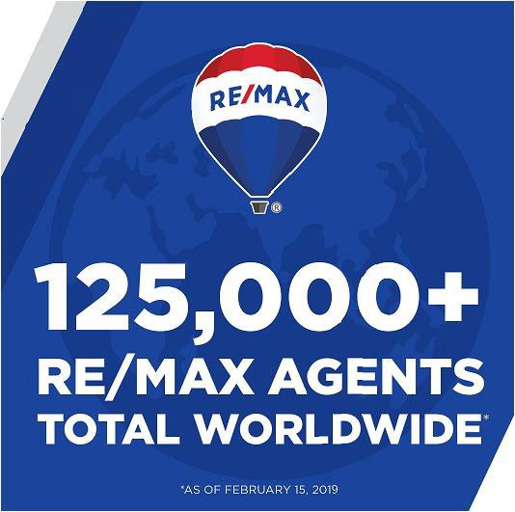

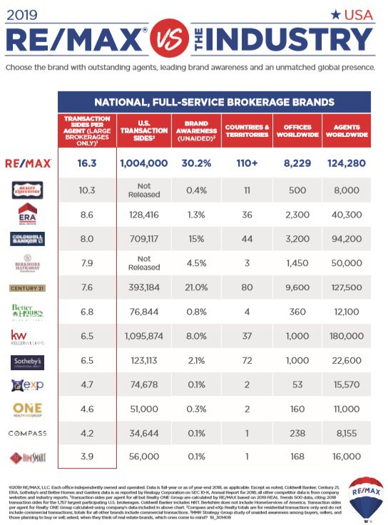

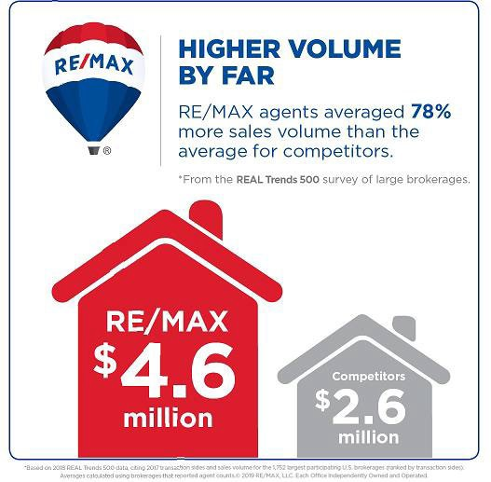

RE/MAX is #1

“Nobody In The World Sells More Real Estate Than RE/MAX”

RE/MAX has been the most searched real estate brand on the internet for the last 5 years.

As shown on the chart below, RE/MAX.com is the most visited real estate brand website. All of the advertising that RE/MAX does on TV, the radio, and in print drives buyers to RE/MAX.com.
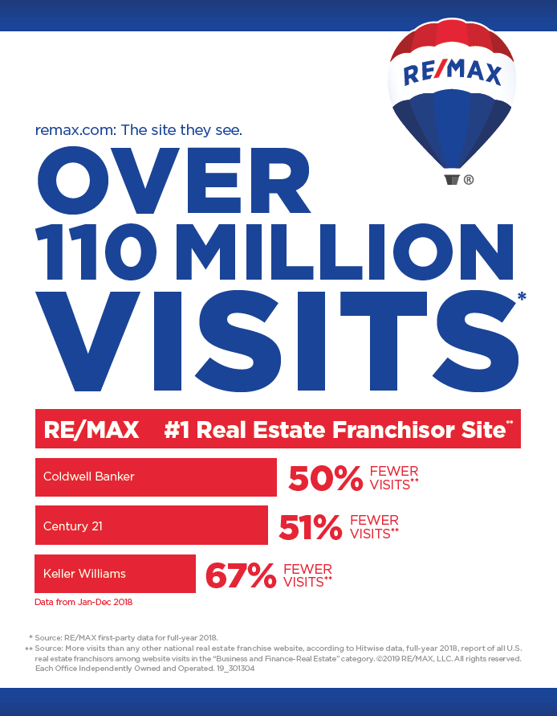

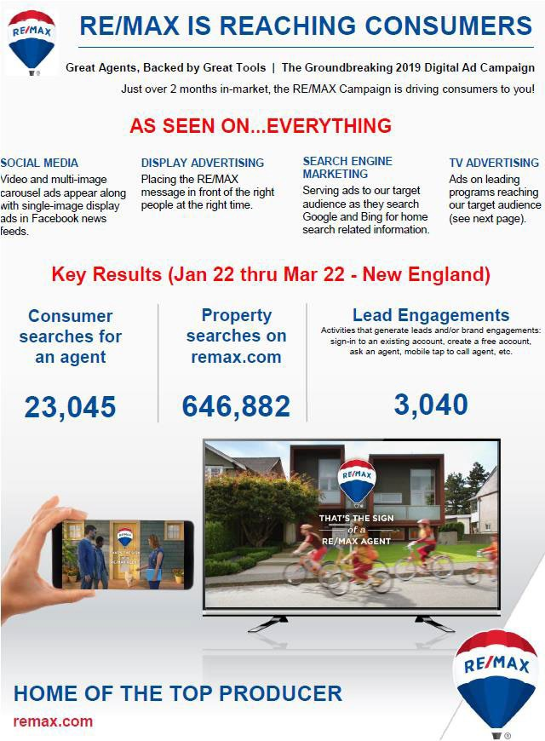

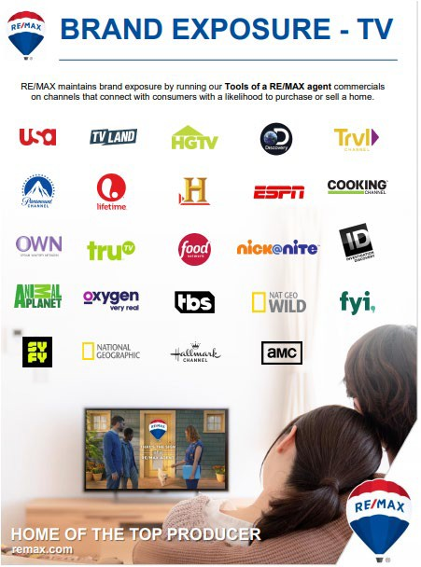

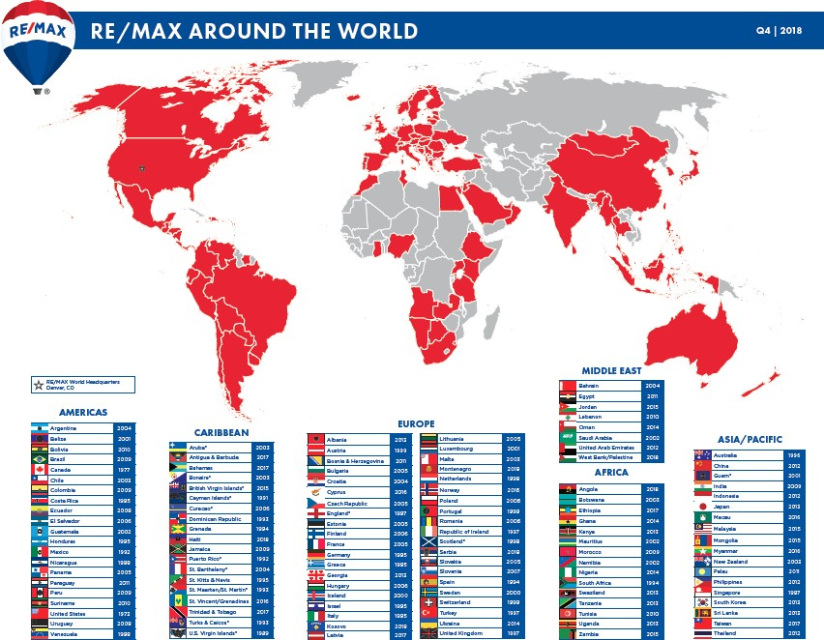

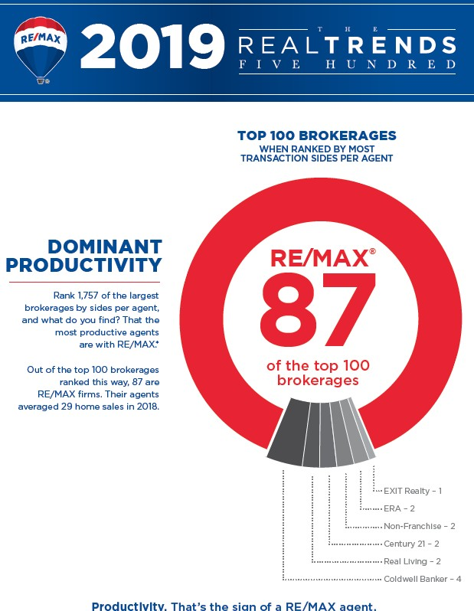

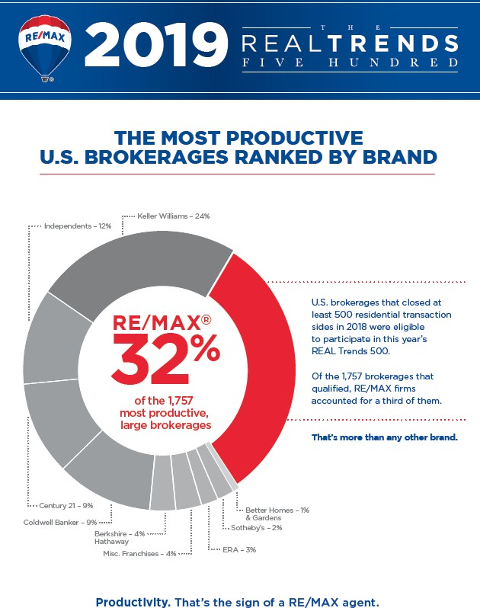

RE/MAX Commercial

We currently have 3,400 RE/MAX Commercial Practioners who completed over 36,500 transactions, representing $14.6B in commercial sales and lease volume, in 2018. We currently have
665 Commercial offices and divisions in 73 countries that have commercial representation.

RE/MAX Associates Give Back

RE/MAX agents and staff have donated over $150 million to the Children's Miracle Network Hospitals. We are the world leader in donations coming directly from agents and staff. By making a donation with each transaction, RE/MAX agents become a Miracle Agent and when all agents in an office make such a donation, the office is known as a Miracle Office.

When an agent or staff member makes a donation, it goes directly to the local Children’s Miracle Hospital. In CT, our local hospital is in Hartford.

A Pledge on Your Behalf

Giving Back

I, along with RE/MAX International, support the Children’s Miracle Network. This charity provides funding for children’s hospitals throughout the United States. It has made important strides in improving the lives of sick children.

I will donate $_______ of the commission from the sale of your home to the Children’s Miracle Network on your behalf. Your home will be a “Miracle Home” with a Miracle sign rider.

Agent Signature

My Focus

To understand your specific needs and wants in order to create a success plan that has the greatest chance of achieving your home sales goal.

No two homes are the same and market conditions change very quickly. My objective is to customize our marketing to your specific situation and needs.

What I know

1. It’s unacceptable to leave your money on the table

2. Homes sell for two reasons: Price and Exposure

3. The pricing game is all about justification...Buyer’s, Buyer’s
Agent’s, Appraisers

4. Pricing is neighborhood/area specific

5. Pricing and Value can change instantly based on daily market
activity. Ex. Closed sales, new listings, price adjustments, etc.

My Three Vital Listing Agent Responsibilities

Marketing and Exposure

Lead Generation...Finding the buyer

Lead Conversion...Closing the buyer

My Role
What you can expect from me as your listing consultant

1. Stay focused on satisfying your needs.

2. Provide continuous comprehensive marketing and recommend the best pricing strategy.

3. Communicate openly and frequently.

4. Respect your time, needs, and finances.

5. Represent your best interests in any and all negotiations.

6. Help prepare your home for effective staging and showing.

7. Withhold any confidential information that will affect the sale of your home.

8. Treat all parties honestly.

9. Always ensure we keep a win-win relationship.

10. Put your interests above all others, including my own.

11. Market and promote your home in a professional manner. (Review plan)

12. Proactively solicit multiple offers.

13. Respond to and resolve all issues quickly and timely.

14. Follow up with other agents who show your home.

15. Provide post-closing information and consulting services and assist you with all future real estate needs.

Your Role

1. Keep home available, presentable, neat, and smelling nice at all times.

2. Follow the agreed upon staging plan. Once you have chosen me as your selling consultant, we
will go back through the home and prepare it for showing.

3. Complete all repairs as agreed.

4. Keep the lawn and exterior of the property ready for showings.

5. Keep valuables and prescriptions in a safe place.

6. Leave home for all showings.

7. Don’t discuss terms with buyers or their agent without me present.

8. Don’t call other agents for feedback.

9. Fill out the Seller’s disclosure forms as accurately as you can.

10. Keep all marketing information displayed and inform me if it is running low.

11. Market your home to friends and acquaintances.

12. Inform me if you will be out of town for more than a day or two.

13. Notify me immediately if your needs or expectations change.

14. Be brutally honest with me if you feel I am not meeting your expectations.

Success Marketing Plan

My Focus
Understand your specific needs and wants in order to create a success plan that has the greatest chance of achieving your home sales goal. No two homes are the same and market conditions change very quickly so our objective is to customize our marketing to your specific situation and needs.

What I Know
- It’s unacceptable to leave your money on the table
- Homes sell for two reasons: Price and Exposure
- The pricing game is all about justification ...Buyer’s, Buyer’s Agent’s, Appraisers
- Pricing is neighborhood/area specific
- Pricing and Value can change instantly based on daily market activity closed sales, new
competitive homes and market condition shift

My Role

What you can expect from me as your listing consultant
- Stay focused on satisfying your needs.
- Provide continuous comprehensive marketing and recommend the best pricing strategy.
- Communicate openly and frequently.
- Respect your time, needs and finances.
- Represent your best interest in any and all negotiations.
- Help prepare your home for effective staging and showing.
- Withhold any confidential information that will affect the sale of your home.
- Treat all parties honestly.
- Always ensure we keep a win-win relationship.
- Put your interest above all others, including my own.
- Market and promote your home in a professional manner. (Review plan)
- Proactively solicit multiple offers.
- Respond to and resolve all issues quickly and timely.
- Follow up with other agents who show your home.
- Provide post-closing information and consulting services and assist you with all future real estate needs.

My Three Vital Listing Agent Responsibilities
- Marketing and Exposure
- Lead Generation Finding the buyer
- Lead Conversion Closing the buyer

Success Marketing Plan

Information technology is changing daily. These changes have a significant impact on the marketing of today’s real estate. According to data recently released by Realtor.com, 95% of all buyers use the Internet to search for their new home. These buyers are 9 times more likely to find their home on the Internet than in newspapers, and 34 times more likely to find a home on the Internet they will consider buying as opposed to spotting it in real estate magazines. That is why we feel it is important to place a heavy emphasis on the Internet when marketing and exposing your home to as many potential buyers as possible.

1. Place in MLS: Prepare and submit your listing to SmartMLS which represents over 18,000 real estate professionals and covers all eight Connecticut counties, making it among the top twenty largest MLSs in the country. Though the third smallest state, Connecticut has the highest per capita income in the United States and boasts a massive $13B in real estate transactions annually.

2. Syndication: Once your home is listed on SmartMLS it will be syndicated to close to 100 websites including remax.com, global.remax.com, Zillow.com, realtor.com, trulia.com, google.com, and yahoo.com.

3. Globalremax.com: The power of global advertising connects your home to an ever-increasing number of national and international buyers. The “No One in the World Sells More Real Estate than RE/MAX” message is seen and heard on network and cable television campaigns, network radio stations, and seen in major consumer print campaigns in publications such as Newsweek, U.S. News & World Report, Money Magazine, and Unique Homes as well as major national newspapers such as USA Today and The Wall Street Journal. All RE/MAX advertising direct buyers to REMAX.com.

4. Professional Photographer: I use a professional photographer in order to show your home at its best. Each photo will be enhanced, thereby presenting your home in its best light.

5. Video of Your Home: One major recent change in the way homes are marketed on the Internet is to include a video of the home within the listing (this is not a Virtual Tour which is simply still pictures in a slide show format). Videos are a significant tool for two reasons:
• Buyers love videos! Per Realtor.com®, a listing with an attached video is 50 times more likely to be viewed than a listing without a video.
• Websites with videos receive a significantly higher ranking on major search engines such as Google and Yahoo.

6. Single Property Website (with the ability to share on Facebook and Twitter) that is specific to your property.

7. Color Home Fliers for potential buyers and their real estate agents.

8. Social Media Posts (with the ability to share on Facebook and Twitter).

9. Facebook ADs as this is a powerful advertising medium.

10. Jumbo Postcard for snail mail marketing.

11. ePostcard for online marketing.

12. Virtual Tour.

13. Home Book for display at the property. It will include photos, home information, disclosures, and additional information for the prospective buyer.

14. Signage - We will maximize the showing potential of your home using professional signage. The National Association of Realtors reports that the sign is one of the top five ways buyers located their home.

15. Drone Photography.

16. 3D Tours.

17. Virtual Staging.

18. Staging: We will suggest constructive staging changes for the property in order to ensure your home shows well. This will help your home yield the highest price the market will allow from interested buyers.

19. Electronic Lock Box: Arrange for and coordinate showings using a high-security electronic lockbox on the property to easily facilitate showings. A record of users is available instantaneously, so we always know who has visited your home.

20. Host Brokers Open House: We will provide lunch to introduce your home to the brokerage community by distributing marketing materials and obtaining feedback from the attending REALTORS®. This extra service provides us ample time to review the features of your home and its benefits.

21. Public Open House: Schedule an open house for the public (if we agree it is appropriate). These are usually held on Sundays from 1:00 to 3:00.

22. Text Marketing: We will attach a rider to the real estate sign in your yard which signals to anyone interested in learning more about the property to use their cell phone to request information via text message.

23. Paid Lead Sources.

24. Office Notification: We will promote your property to our agents and staff within 24 hours of it being listed on SmartMLS.

25. Seek Potential Buyers: We will contact our buyer leads, spheres of influence, and past clients to look for potential buyers for your home.

26. Send Flyer to Neighbors: We will send a “New Listing” flyer to residents in your immediate neighborhood promoting the features and lifestyle benefits of the home.

27. Door Knock: 30 closest neighbors.

28. Call 50 neighbors.

29. Notify area’s top agents.

30. Communication: Follow up on showings and advise you of results and comments.

31. Seller’s Weekly Progress Report: Sold properties, competition in the market, absorption rate, showings, feedback from showings will be sent to you periodically
Syndication
AdWerx ApartmentList Assist-2-Sell
Back At You Media Breakthroughbroker century21.com Digiprooz DreamHomeList Equator
FindAPlace4Me by Paradym Flipcomo
Foreclosure.com Foyer
Harmon Homes
Home2 me by TourFactory HomeBidz HomeFinder.com HomeJob HomePriceTrends Homes&Land
Homes.com HomeSpotter HomeSteps HomeValueStore HomeWinks Hommoli HouseHunt.com Houses.net
IdealEstate HousesForSale
International Property Network Juwai
Kahping KE.com Keyboom LakeHomesUSA Land On Earth
LearnMoreNow.com/findhomes Listingvideos by Vscreen LofNetwork.com LuxaryRealEstate.com Mashvisor
MassLive.com MobileHome.net MyRentToOwn.com nest.me
NestHawk Nestigator NestReady
New Home Source Nobbas ParkBench
PNC
Point2 Homes Properties Online Property Path
Property Shark Property Simple
Propstream by Equimine RE/MAX
RE/MAX.com Metrics RealQuest Express RealtyExecutives.com RealtyStore RealtyTrac
Redius Rent.com Rentberry RentHop RentRange
Search ALL Properties by L2L The Land Network
The Real Estate Book TotalExpert
Tri-State Area Trulia USHUD.com VisualShows WikiReally Ylopo
Zillow Zonda Zummer

Seller’s Closing Costs

At the closing you, the Seller, will have a number of closing costs. In most circumstances these costs will be deducted by your attorney from the proceeds of the sale of your home. Below is a list of the most common closing costs in Connecticut.

Prior to the closing your attorney is required to provide you with a list of all closing costs. If he or she does not, ask for it.

State Real Estate Conveyance Tax
- Houses selling for $800,000 or less:
- 0.75% of the sales price
- Houses selling for over $800,000:
- $6,000 plus 1.25% of the sales price over $800,000
Municipal Real Estate Conveyance Tax
- 0.25% of the sales price in all Municipalities except those listed below.
- 0.50% of the sales price in the following Municipalities:
    - Bloomfield, Bridgeport, Bristol, East Hartford, Groton, Hamden, Hartford, Meriden, Middletown, New Britain, New Haven, New London, Norwalk, Norwich, Southington, Stamford, Waterbury and Windham
Attorney Fees
Brokerage Fee
Municipal Recording Fees
Home Warranty Plan Fee
- The cost of your Home Warranty Plan if you have elected this option

Field Card

